

Total 26 questions.
20 MCQS.
6 Subjective.
12 MCQS are from past papers.

Subjective questions:
Q: 21: How a circuit with multiple outputs is shown in truth table? MARKS: 3:

Q: 22: Define Sequential Circuit. MARKS: 2:
Answer:
Digital circuits that generate a new output on the basis of some previously stored information and the new input are known as Sequential circuits.

Q: 23: Apply each of the following sets of binary numbers to Comparator inputs in figure and determine the output by following logic levels of the Circuit. MARKS: 5

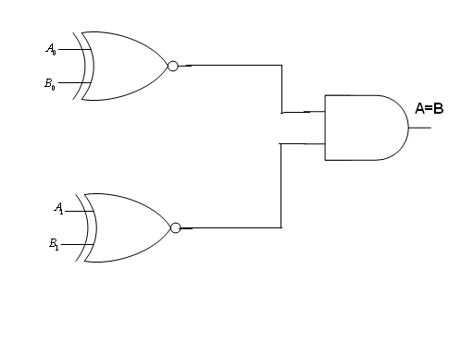

- A= 10, B= 10.
- A= 11, B= 10.

Q: 24: Write uses of demultiplexer. MARKS: 5:

Q: 25: How decorder is used as demultiplexer.
MARKS: 3:

Q: 26: Two-bit iterative comparator circuit for comparison A=B. Explain functionality of the Circuit.
MARKS: 3:


